# CS 255 System Design Document Template

This template lays out all the different sections that you need to complete for Project Two. Each section has guidance to prompt your thinking. You will need to continually reference the interview transcript as you work to make sure that you are addressing your client’s needs. There is no required length for the final document. Instead the goal is to complete each section based on what your client’s needs are. Remove this note when you are finished, and replace all bracketed text with the relevant information.

## UML Diagrams

### UML Use Case Diagram

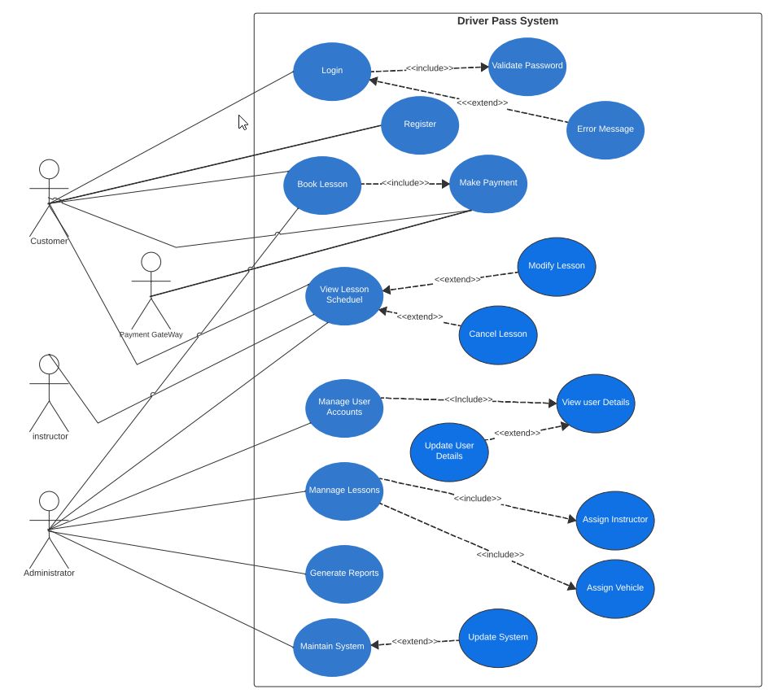

### UML Activity Diagrams

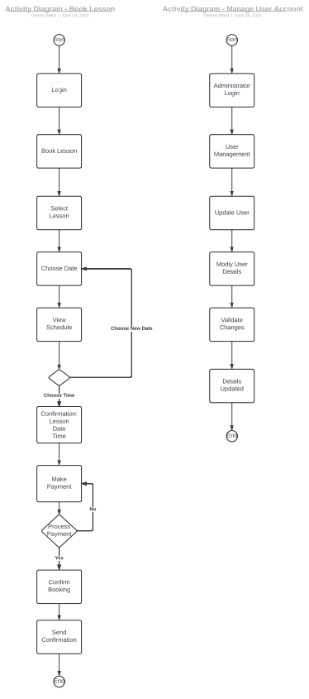

### UML Sequence Diagram

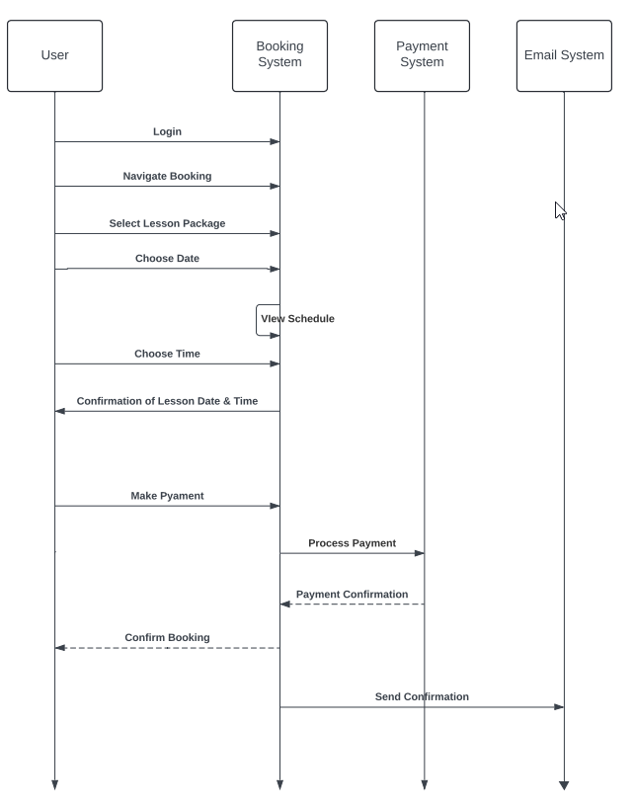

### UML Class Diagram

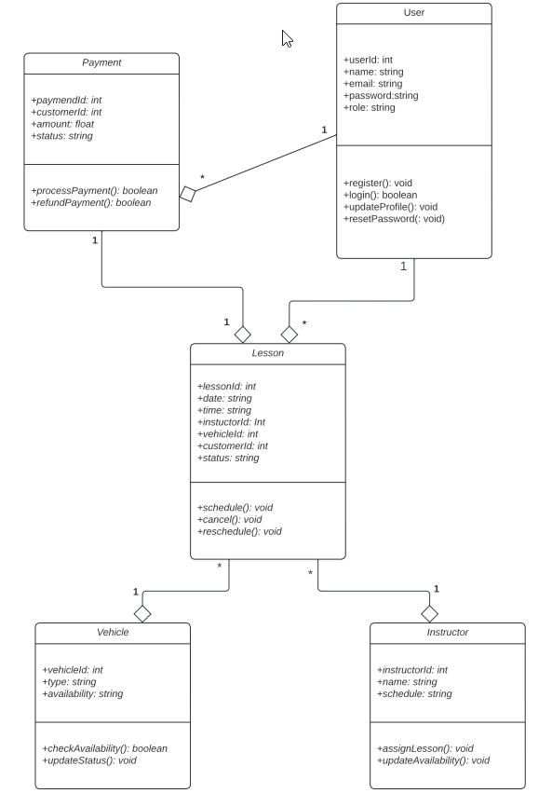

## Technical Requirements

**Hardware Requirements**

The DriverPass system needs high-performance servers with modern multi-core processors, plenty of RAM (32 GB minimum), and fast SSD storage (at least 1 TB). These servers will handle all user requests efficiently. Users will access the system on PCs, tablets, and smartphones, so it’s important that the devices are modern and have stable internet connections with speeds of at least 100 Mbps.

**Software Requirements**

The system should run on both Windows and Unix servers and be accessible from any modern operating system, including Windows, macOS, iOS, and Android. We will use a reliable database like MySQL or PostgreSQL to manage data. For the web server, we recommend Apache or Nginx. Java will be used for the backend with the Spring Boot framework, and HTML, CSS, and JavaScript (using Angular or React) for the frontend.

**Tools and Infrastructure**

For development, we will use IntelliJ IDEA or Eclipse as our coding environments and manage our code with Git on platforms like GitHub or GitLab. Maven or Gradle will help us manage project dependencies. To create our UML diagrams, we will use Lucidchart, which makes it easy to visualize system design.

**Security**

Security is critical. We will use HTTPS to secure data transfer and implement user authentication with username and password, plus optional two-factor authentication. Data will be encrypted using SSL/TLS, and the system will alert us to any security issues. After three failed login attempts, accounts will lock temporarily, and users can reset their passwords via email.

**Performance and Accessibility**

The system should be quick, loading within two seconds, and able to scale as more users join. Monthly updates will keep it secure and functional without causing downtime. It will be accessible on all devices, with a user-friendly interface.

**User Management**

We will use role-based access control to give different permissions to customers, administrators, and instructors. An admin panel will allow easy management of user profiles without needing to change any code.

**Summary**

These requirements ensure that DriverPass will be fast, secure, and easy to use. By focusing on performance, accessibility, and security, we aim to provide a great experience for everyone using the system. If any changes are needed, we can adjust these requirements accordingly.